Shaving Brush Kits Assembly Instructions
Required Accessories
• 7mm pen mandrel
• 7mm Drill bit BPD-7MM-PRC
• 7/8” dia Forstner bit
• 2 pcs. bushings set BUSH-SHAVEBRUSH
• Wood Blank (or acrylic) 1-1/2” x 1-1/2” x 2-1/2” (or longer)
• 2 part epoxy glue or insta-cure (cyanoacrylate)
• Shaving Brush with 20mm dia base CT-SHAVEBRUSHNSB
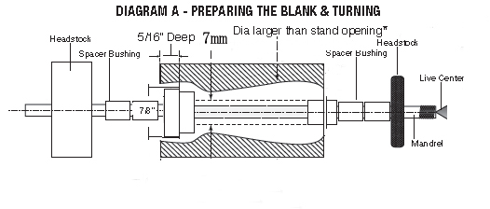
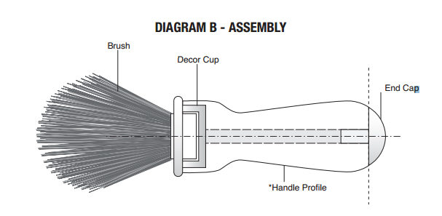

Preparing & Turning The Blank/Assembly
• Prepare a blank (wood or acrylic) min of 1-1/2” x 1-1/2” x 2-1/2”
• Drill a hole 5/16” deep, in one end with a 7/8” forstner bit.
• Use the center mark of the forstner bit to center and drill a 7mm hole through the blank.
• Mount the bushing and blank over the mandrel according to Diagram A .
• Turn the blank to the profile suggested in Diagram A in order for the brush to hang correctly. Follow the measurements indicated. IMPORTANT: Turn the profile of the blank to fit your stand opening.
• Finish the handle with waterproof sealer for wood.
• Remove the handle off the mandrel. Glue the brush base into the decor cup. Glue the assembly into the recess in the handle. Glue the end cap into the opposite end of the handle.

